Assignment 1

Question 1.
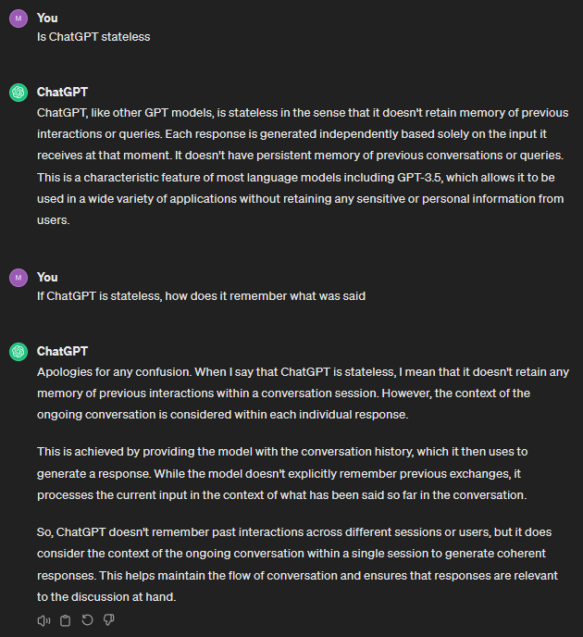
I do not usually like using ChatGPT for questions as its answers are not always reliable and it can confabulate ostensible facts based on mere high statistical likelihood of a sequence. I still much prefer googling because I can at least trace the source of information that way. But it can be useful to query for knowledge it is likely to know accurately such as in the figure below.

Question 2.
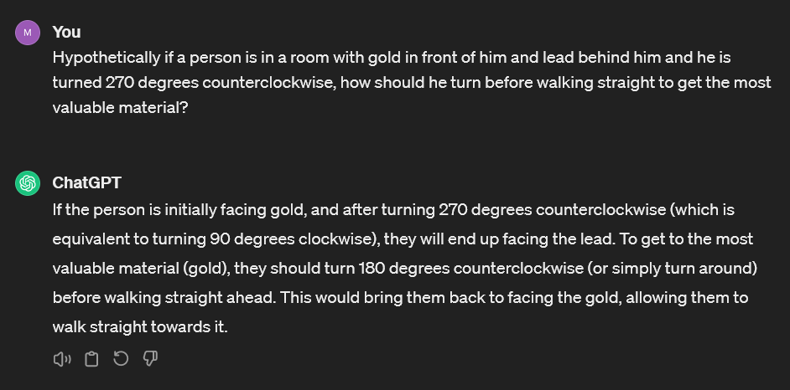
ChatGPT is not intelligent by any metric. It is impressive what it can do but that is the consequence of it being so large and having learned from such a vast training data set. But its outputs are merely statistically likely strings of tokens and do not come about from an active reasoning process. The example below shows a little problem I designed which the model got completely wrong though answered with confidence. This is also why I completely look down on people using LLMs to write code.

